Getting started with GAMBAS

What is Gambas?
Gambas is a Linux free integrated development environment (IDE) base on a Basic interpreter, like Visual Basic. It is a Basic language with object extensions whose syntax will be familiar for developers who have used Visual Basic. One of the virtues of Gambas is that fully integrate 3 very important elements to make a usable programming language: the language itself, and modern and easy IDE, and the interface objects toolkit. This tutorial will get you up to speed on Gambas programming.

Welcome to Gambas
Gambas is the fastest and easiest way to create Linux application. Regardless you are new or experimented in Linux programming, Gambas provides a very complete toolbox of widgets (known as controls in Windows world) that simplify the rapid development of applications.

Installing Gambas
Refer to the Gambas home page (http://gambas.sourceforge.net/) for download the latest version and follow the instructions for compiling & installing. Also you can install Gambas from your distribution repository.

Where to get help
It is a undeniable fact that documentation is a very important part of useful software. Probably at this point, you already find out that one of the biggest issues in the free and free software is not the software itself, but the lack of good and updated tutorials or manuals. The majority of the good FOSS aren't accompanied by full manuals. Gambas has a lot of good samples as part of the installing package, and there is good documentation and examples on line. My recommendations is to you get familiar with the material of the following links:
● http://gambas.sourceforge.net/
● http://gambasdoc.org/help
● http://www.gambasforge.net/
You can also subscribe to mailing lists and forums.

Developing applications in Gambas
Only will take a few minutes to build your first application in Gambas. The graphic user interface (GUI) will be quickly created by drawing on the form widgets like text boxes or command buttons. Then you will set some properties to the form and widgets to specify values like text, color or size. Finally, some code must be written to bring to life your application. Those basic steps that you'll use to create your first application, will show you the principles that you will use for develop any other application in Gambas.
This tutorial provides a review or the developing application process and describe the terms and skills you need to use Gambas and will guide you step by step trough few simple applications.

Interactive development
Gambas allows the interactive development, in other words, run the application frequently during the development, instead of write, compile and then test the code. With this technique you can see the results of your code while you still working on it, instead of waiting to compile.

IDE elements
One of the greatest roadblocks on Linux programming is that most of the languages don't not fully integrated the language itself, the GUI framework and the IDE. The Gambas IDE provides a nice set of tools to develop the GUI and every object on the form can be coded as required by the application. This tutorial refers to the IDE elements as follows: Menu bar, Tool bar, Tool box, Project visor, Form designer, Properties visor & Code editor.

Say Hello to the world
“Gambas is the fastest and easiest way to create Linux application”. Oh! really, how fast In order to find it out, lets try the following “Hello world”.
1.- Fire up your Gambas IDE, then on the Welcome screen select New project. This opens the New project Wizard. | 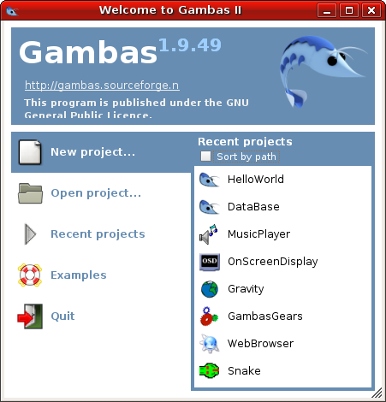
2.- On screen 1 select QT graphical application. | 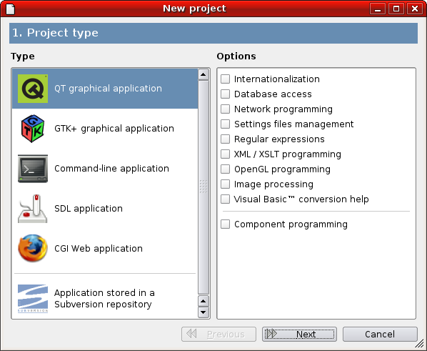
3.- Select a location to save your project. My recommendation is you to create a folder named “Projects” to save all projects related to this tutorial. | 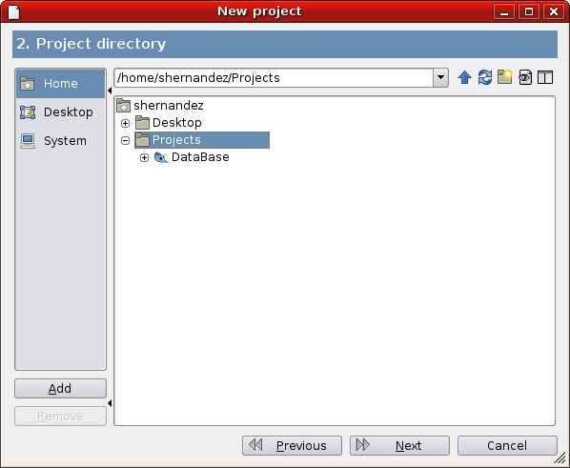
4.- Type a name for your project. For this lesson you'll name the project “HelloWorld” (with no spaces) and as title type “Hello World”. Accept any dialog that could been shown. | 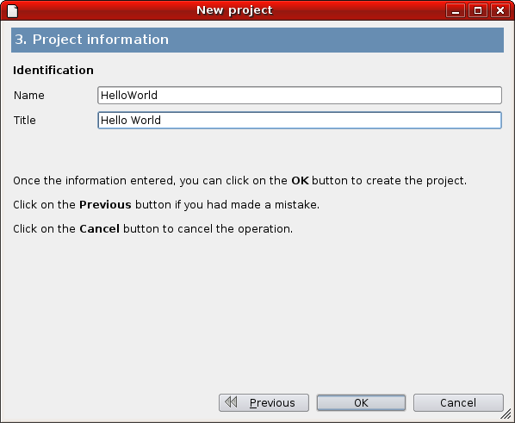
5.- On the Project viewer from the contextual menu of Forms>FMain select Edit form. Now you are ready to start.  Tip: Explore all tabs of widgets available on the Toolbox. | 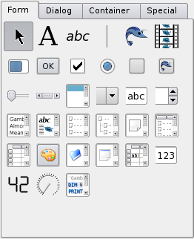
Do you remember the basic steps to create a Gambas application?
- Create the interface.
- Set properties.
- Write code.

Creating the GUI
Forms are the base to create the application GUI by adding widgets, other forms and dialog boxes to your application.

To draw a widget using the toolbox
- Click over the tool for the widget you want to draw.
- Move the cursor inside the form.
- Put the cursor where you want to set the upper-left corner of the widget.
- Drag the cursor until the control be the size you want. “Drag” means hold the mouse's left button while move an object with the mouse.
- Release the mouse button and the widget will appear over the form.
Or you can double click over the tool's widget and a default size widget will appear in the upper-left corner of the form, then you can move it to other location in the form.
For this first application you will use three widgets form the toolbox: a Label, a Text box and a Button.

Setting properties
The next step is set properties to the object you create. The Properties visor makes this task very easy. You can open the Properties visor selecting from the Menu bar or using the widget's contextual menu (right click over the widget)

To set properties
- Show the Properties visor for the selected object.
- From the properties list select the name of the property.
- On the right column type or select the new setting for the property.

Set the properties for the widgets you just created according the following table:
Control | Property | Setting
Label1 | Text | “Tell me your name:”
Label1 | Alignment | Center
Button1 | Text | “&Hello”
TextBox1 | Text | “Write your name here”
FormMain | Text | “My first Gambas project”
Now arrange the widgets to look like this:
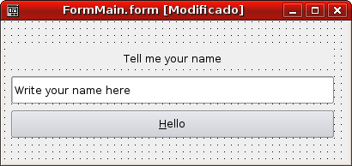

Writing the code
The Code editor is where you write the code for your application. The code is a set of language statements, constants & declarations.

To open the Code editor
Double click over the object you want to write code or on the Resources visor select the name of the form or module and from the contextual menu select Edit class.

Creating Event Procedures
The code in Gambas is divided in small blocks called procedures. An event procedure (knows as slots in QT language), like the ones you will create for this lesson, contains the code that will be executed when an event occurs, such as when a user clicks a button. An event procedure combine the name of the object (defined in the property name), a underscore (“_”) and the name of the event. For instance, if you wish a button named Button1 call an event procedure when it is clicked the procedure will be named Button1_Click().

To create an event procedure
- Select the object.
- Double click over the object to write the code for the default event. In the specific case of the button is the Click event. Or you can use the widget's contextual menu and select the required event. Note that a template for the procedure is inserted in the Code editor.
- Write the code between the statements PUBLIC SUB & END SUB. For this lesson write the following code:
Label1.Text = "Hello " & Textbox1.Text & ". This is my first Gambas project!".
The code for the procedure must be look like this:
PUBLIC SUB Button1_Click()
Label1.Text = "Hello " & Textbox1.Text & ". This is my first Gambas project!"
END SUB
As you can see the code consists just change the property text of the Label1 widget to “Hello <some text>. This is my first Gambas project!”. The syntax for this sample is very simple: object.property. Where object is Label1 and Text is the property. You can use this syntax to change the properties of any object, forms or widgets, in response to events that occur while your application is running.

Running the application
In order to run the application select Debug>Run from the Menu bar or click over the start icon on the Tool bar or press [F5] on the keyboard.
Now type your name on the text box replacing the current text. Input your name and click the Hello button and if your name is “Ricardo Arjona” you'll see the following result. As you can see develop Linux application with Gambas is indeed fast and easy. Save your project, select File>Save project from the Menu bar.
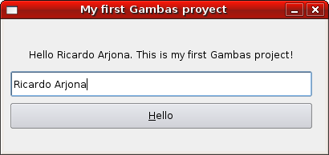
Gambas provides lot more tools that the used in this first application so sooner you will use many other features to manage and customize your applications. Review the samples code included on the Gambas package is an excellent way to learn more about all the kind of applications you can develop with Gambas. And who knows, probably you will develop the killer app that the open source community is expecting. Refer to http://en.wikipedia.org/wiki/Killer_application if you want to learn more about the “killer app” concept.

Designing a GUI
The easiest way to allow users interact with applications is providing visual objects, like buttons or menus, over the forms, that the users can click to produce a result. You can use the button widget on the toolbox or create your own buttons using a PictureBox widget containing a graphic as an icon. The GUI concept was the breakpoint in the personal computer history, an idea invented by Xerox, commercially developed by Apple, and later stolen by Microsoft, well, it's what I heard.

Common widgets on GUI's
Tex boxes, labels, buttons, menus, check boxes, radio buttons, combo boxes, list boxes, probably are the most commonly used widgets to develop GUI's, so they are a good point to start. Create a new project named “CommonWidgets” using the same parameters of the previous lesson.
Create the following widgets and set the properties as follows:
Control | Property | Setting
FMain | Text | “Common Widgets”
Label1 | Text | “Who is the best soccer player in the history?”
RadioButton1 | Text | “Pele”
RadioButton2 | Text | “Maradona”
RadioButton3 | Text | “Santi Munez”
RadioButton4 | Text | “Other”
Label2 | Text | “(Please specify)”
Label2 | Enabled | False
TextBox1 | Text | (Empty)
TextBox1 | Enabled | False
Button1 | Text | “1.- Calculate I&Q”
Separator1
CheckBox1 | Text | “Do you think this is a Killer App?”
Button2 | Text | “2.- &Calculate IQ”
Separator2
Label3 | Text | “Select your favorite movie”
ComboBox1 | List  (This property has its own editor. Insert the list elements as required.) | Matrix  Die Hard  Shrek
ComboBox1 | Sorted | True
Button3 | Text | “3.- C&alculate I&Q”
Separator3
Label4 | Text | “Select your favorite color”
ListBox1 | List  (This property has its own editor. Insert the list elements as required.) | Black  White  Red  Blue  Green  Yellow
ListBox1 | Sorted | True
Button4 | Text | “4.- Ca&lculate I&Q”
Separator4
Button5 | Text | “E&xit”
Button5 | ToolTip | “I'm out of here. This is non sense!!!”
Arrange all objects to look as the following picture.
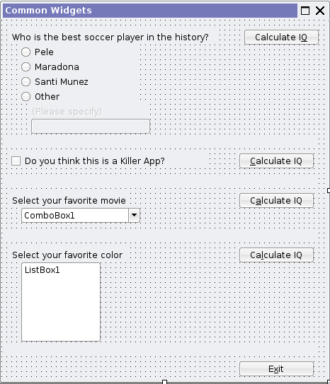
If you run the application at this point you will see a nice form but without any functionality. So you need to start to write some code.
Double click on the Exit button (Button2), and add the following code between the statements PUBLIC SUB & END:
- PUBLIC SUB Button2_Click()
- Message.Info("Bye, bye!!!", "Exit")
- FMain.Close()
- END

When you click the “Exit” button the effect will be that a dialog is shown with the Info icon, the message “Bye, bye!!!”, and a button with the text “Exit”. Rewrite the line 2 to Message.Info("Bye, bye!!!") and rerun to see what happen. As you can see if you omit the second argument, a default button “OK” is shown. Finally in the line 3 the form Fmain calls the its method Close() closing the application. Now you can understand the benefits of interactive development, you can review the effects of your code while you still developing it.
You can learn more by exploring the local Gambas Documentation that you get when press [F1]. By the way, as you remember you select the option QT graphical application from the New project wizard, that means that most of the help you will need is under the Gambas Component gb.qt.
When you run the application you surely note that the “Please specify” label and the text box are always disabled but you want enable them when the “Other” ratio button is selected. Lets write some code to fix this behavior. Write code for the Click event on the RattioButton4 widget as following:
- PUBLIC SUB RadioButton4_Click()
- IF RadioButton4.Value = TRUE THEN
- Label2.Enabled = TRUE
- TextBox1.Enabled = TRUE
- ELSE
- Label2.Enabled = FALSE
- TextBox1.Enabled = FALSE
- ENDIF
- END
When the user click “Other” the event procedure evaluates what the value of RadioButton4 is (line 2), if is true enable the two widgets (lines 3 & 4), else (line 5) disable them (lines 6 & 7). When a IF statement perform more than one line of code need to be closed with the ENDIF statement (line 8). This event procedure will work for the other 3 radio buttons, so copy-paste the same code for all radio buttons Click events (there is a better way to do this but for this lesson lets do it like this). This decision structure is known as IF-THEN-ELSE.
Now the final touch, lets write code for the “1.- Calculate IQ” button Click event. Write the following code, then run the application, play a little with the possible selections, evaluate them, and lets see if you can figure out how the code is affecting the result.
- PUBLIC SUB Button1_Click()
- DIM SoccerPlayer AS String

- 'Evaluates the selected RadioButton to know the selected player
- IF RadioButton1.Value = TRUE THEN SoccerPlayer = "Pele"
- IF RadioButton2.Value = TRUE THEN SoccerPlayer = "Maradona"
- IF RadioButton3.Value = TRUE THEN SoccerPlayer = "Santi Munez"
- IF RadioButton4.Value = TRUE THEN SoccerPlayer = TextBox1.Text

- 'Shows a message for the selected option
- Message.Question("You select " & SoccerPlayer & ". Are you crazy?", "Yes", "No", "Maybe")
- END
First you declare a string variable named SoccerPlayer (line 2), depending on what radio button is selected the variable SoccerPlayer will store the name of the selected player (lines 5 – 8). Dialog box is shown with a message and the name of the selected player (line 11). Lines 4 & 10 are comments that don't have any effect on the application, but for the programmer are very useful, especially if you are team working on a big project. The Gambas interpreter will ignore all lines beginning with an apostrophe (').
Gambas provides the SELECT-CASE structure as alternative for the IF-THEN-ELSE for selectively execute one block of statements from among multiple block of statements. It is the same functionality of the IF-THEN-ELSE but it is more readable when there are many choices. Lets see the SELECT-CASE structure in action, write the following code for the “3.- Calculate IQ”:
- PUBLIC SUB Button3_Click()
- 'Evaluates the selected movie
- SELECT CASE ComboBox1.Text
- CASE "Matrix"
- Message.Warning("You are a NERD!?!?!?", "Am", "I", "Right?")
- CASE "Die Hard"
- Message.Error("Hasta la vista baby")
- CASE "Shrek"
- Message.Info("I kind of like you!")
- END SELECT
- END
Depending on the selected movie (value of the property Text from the ComboBox1) different messages are shown (lines 3 – 10).

Exercise:
- Modify the code for the “1.- Calculate IQ” to display different messages depending on the value of the SoccerPlayer variable.
- Add code to the “2.- Calculate IQ”. If the user don't consider the application a Killer app, show a Message.Error dialog “Why not?”
- Write code for the “4.- Calculate IQ” button using the decision structure SELECT-CASE. Try to guess the nationality of the user based on the selected color showing a Message.Question dialog “Are you <nationality>?” with two buttons “Yes” & “No”.

See you in the next lessons!!!
Comments? info.geex@gmail.com

Copyright (c) Sergio Hernandez
Permission is granted to copy, distribute and/or modify this document
under the terms of the GNU Free Documentation License, Version 1.2
or any later version published by the Free Software Foundation;
with no Invariant Sections, no Front-Cover Texts, and no Back-Cover
Texts. A copy of the license is in the following link GNU Free Documentation License.Getting started with GAMBAS

